Student Number:

**YEAR 11 EXAM**

**ECONOMICS: STAGE 2**

**SEMESTER 1 2012**

**QUESTION/ANSWER BOOKLET**

### Time allowed for this paper

10 minutes reading time

3 hours writing time

### MATERIALS TO BE PROVIDED FOR THIS PAPER

#### To be provided by the supervisor

This Question/Answer Booklet

Multiple Choice Answer Sheet

#### To be provided by the candidate

## Standard items: Pens, pencils, eraser or correction fluid, and ruler

Special items: A 2B, B or HB pencil for the Multiple Choice Answer Sheet and

calculators satisfying the conditions set by the Curriculum Council for this subject.

***NO GRAPHIC CALCULATORS***

### Important note to candidates

No other items may be taken into the examination room. It is **your** responsibility to ensure that you do not have any unauthorised notes or other items of a non-personal nature in the examination room. If you have any unauthorised material with you, hand it to the supervisor **before** reading any further.

**Structure of the Paper**

|  |  |  |  |  |  |
| --- | --- | --- | --- | --- | --- |
| *Section* | *Format* | *No. of questions* | *No. of questions to be attempted* | *Suggested time in minutes* | *Marks* |
| One | Multiple Choice | 30 | 30 | 45 | 30 |
| Two | Data Interpretation | 5 | 5 | 90 | 50 |
| Three | Extended Response | 2 | 1 | 45 | 20 |
|  |  |  |  | **TOTAL** | **100** |

**Section One: Multiple Choice 30% (30 marks)**

This section has **30** questions. Answer **all** questions on the separate Multiple-choice Answer Sheet provided. For each question shade the box to indicate your answer. Use only blue or black pen to shade the boxes. If you make a mistake, place a cross through that square, do not erase or use correction fluid, and shade your new answer. Marks will not be deducted for incorrect answers. No marks will be given if more than one answer is completed for any question.

Suggested working time: 45 minutes.

1. The economic problem is a problem of scarcity because

(a) consumers cannot purchase all their wants.

(b) there are insufficient resources relative to the consumers’ wants.

(c) production surpluses will occur in all markets.

(d) goods and services are purchased at high prices.

2. The opportunity cost of going to the movies with a friend would include

(a) the cost of the ticket but not the enjoyment of a TV show missed.

(b) the cost of the ticket and the cost of the friend’s ticket.

(c) the cost of the ticket and the loss of enjoyment of a TV show missed.

(d) the cost of the ticket.

3. The real cost or opportunity cost refers to the

(a) underlying value of the resources used in production

(b) dollar cost of the factors used in production

(c) transfer value of an alternative combination of output

(d) value of the next best alternative that is forgone in production

4. The economic problem implies that

(a) all of society’s wants can be satisfied by the availability of resources.

(b) regardless of the relative abundance of some resources, they will always be

scarce relative to wants.

(c) limited wants can be satisfied by using unlimited factors of production efficiently.

(d) a society that can maximise the opportunity cost of its production choices will

always be better off.

5. Two key characteristics of a market economy are

(a) efficient allocation of resources and equitable distribution of income.

(b) private ownership of resources and steady economic growth.

(c) producer sovereignty and price controls set by the government.

(d) consumer sovereignty and the price mechanism.

6. Transactions in factor markets involve

(a) resources used in production exchanged for household income.

(b) goods and services exchanged for household income.

(c) goods and services exchanged for consumption expenditure.

(d) resources used by households exchanged for income.

7. The factor "enterprise" is different to "labour" as enterprise

(a) is paid more than labour resources

(b) involves risk taking whereas labour does not

(c) earns profit and interest whereas labour receives a wage.

(d) is a capital resource whereas labour is a human resource

Questions 8 to 12 refer to the following diagram

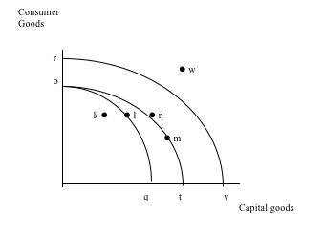

O

8. A shift in the production possibilities curve from Oq to Ot may be caused by

(a) an increase in productivity for consumer goods

(b) an overall improvement in productivity for both goods

(c) an increase in productivity for capital goods

(d) more of the existing resources being used to produce capital goods

9. Point k indicates that the economy is operating at

(a) full employment of existing plant equipment

(b) optimal capacity of existing plant and equipment

(c) under employment of existing plant and equipment

(d) an efficient combination involving fewer capital goods and more consumer goods

10. A shift from curve oq to rv can occur when

(a) there is an improvement in technology or an increase in resource availability for both goods

(b) there are structural changes in the capital goods sector allowing efficiency flow-ons.

(c) existing resources and the level of technology are used most efficiently and output in both goods maximised

(d) there is a general economic expansion involving an increase in both average wages and the general price level

11. Given that other variables remain constant

(a) fewer consumer goods are produced at point n as compared to combination m

(b) future economic growth is likely to be higher with combination m as compared to n

(c) the current standard of living must be higher by producing at a combination m as compared to n

(d) economic growth will move the economy to a more optimal combination m as compared to n

12. A point w is currently unobtainable since

(a) the economy does not require this level of economic growth

(b) some resources must remain in reserve for use in future production periods

(c) restructuring has not occurred in the workplace to allow this level of production

(d) all available resources and level of technology are being fully utilised

13. The quantity demanded will fall when price rises in a market because of

(a) substitution and complement effects.

(b) income and substitution effects.

(c) consumer and producer effects.

(d) income and consumer choice effects.

14. Which one of the following is a factor that may increase the level of demand for a good?

(a) a fall in the price of resources used to produce the good

(b) a fall in the price of the good

(c) a fall in the price of complementary goods

(d) a fall in the price of substitute goods

15. If both the demand and the supply of a good decreases, it could be predicted that

(a) equilibrium price and equilibrium quantity will rise.

(b) equilibrium price and equilibrium quantity will fall.

(c) equilibrium price will fall but the change in equilibrium quantity cannot be determined without further information.

(d) equilibrium quantity will fall but the change in equilibrium price cannot be

determined without further information.

16. The diagram below represents the market for wheat.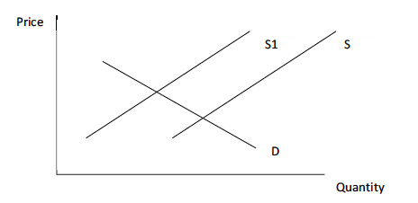

The shift in supply from S to S1 is best explained by

(a) a fall in the global wheat price.

(b) poor growing conditions in a number of grain-growing countries.

(c) a shift in consumer preferences toward rice.

(d) the development of a faster-growing strain of wheat.

17. If the quantity supplied is less than the quantity demanded, then a

(a) surplus exists and the price will fall.

(b) shortage exists and the price will rise.

(c) surplus exists and the price will rise.

(d) shortage exists and the price will fall.

18. The equilibrium price in a competitive market will rise when demand

(a) increases proportionally more than supply increases.

(b) and supply increase by the same amount.

(c) decreases proportionally more than supply decreases.

(d) expands and supply remains constant.

19. If demand for a good contracts from 1000 units to 900 units as a result of a 15% price rise, then demand is

(a) elastic.

(b) unitary elastic.

(c) inelastic.

(d) inverse.

20. A contraction in the supply of beef is most likely to be caused by

(a) a decrease in the price of pork

(b) drought conditions in cattle grazing areas

(c) a decrease in the price of beef

(d) a tax placed on the production of beef

21. A good for which the supply is perfectly inelastic has a supply curve which is

(a) a vertical straight line.

(b) a horizontal straight line.

(c) backward sloping.

(d) forward sloping.

22. Which one of the following would be most likely to have negative income elasticity?

(a) jewellery

(b) restaurant meals

(c) sausages

(d) champagne

23. Bubbles and Twammy are two brands of cola soft drink. They can be classified as

_________________________ , and therefore their cross-elasticity of demand will be _______________________________ .

The missing words are, respectively:

(a) substitutes; zero

(b) complements; one

(c) substitutes; negative

(d) substitutes; positive

24. If a person pays $100 to attend a concert, but they were willing to pay $150, then the person’s consumer surplus is

(a) $100.

(b) $250.

(c) $150.

(d) $50.

25. A government would be most likely to increase the sales tax on a particular product that it believed to be

(a) price inelastic.

(b) price elastic.

(c) cross inelastic.

(d) income elastic.

26. Which of the following statements about price elasticity of supply is most valid?

(a) The elasticity of supply is dependent on consumer demand.

(b) The longer the time period, the more inelastic supply will become.

(c) The longer the time period, the more elastic supply will become.

(d) All goods are to some extent supply elastic.

27. Which one of the following goods would be the most supply inelastic?

(a) hamburgers

(b) soft drinks

(c) airplanes

(d) motor vehicles

28. A reduction in production costs will

(a) increase the consumer surplus.

(b) decrease the consumer surplus.

(c) reduce the total welfare.

(d) not change total welfare.

29. Total surplus is

(a) consumer surplus minus producer surplus.

(b) total benefits minus total costs.

(c) maximised when consumer surplus is greater than producer surplus.

(d) maximised when consumer surplus is equal to producer surplus.

30. Resources are allocated efficiently in a market when

(a) total surplus is minimised.

(b) deadweight loss is maximised.

(c) deadweight loss is minimised.

(d) total surplus is greater than consumer surplus.

**Section Two: Data Interpretation/Short Response. 50% (50 marks)**

This section contains **five (5) questions. Answer all** questions. Write your answers in the space provided.

Suggested working time: 90 minutes.

**Question 31 (5 marks)**

(a) Why is economics often referred to as a social science? (1 mark) __________________________________________________________________________________________________________________________________________________________________________________________________________________

(b) Define the four factors of production and give an example of each.

(4 marks)

* 1. ______________________________________________________________________________________________________________________________________________________________________________________________________
  2. ______________________________________________________________________________________________________________________________________________________________________________________________________
  3. ______________________________________________________________________________________________________________________________________________________________________________________________________
  4. ______________________________________________________________________________________________________________________________________________________________________________________________________

**Question 32 (10 marks)**

Refer to the diagram below to answer the following questions:

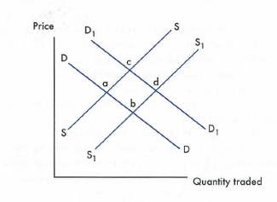

(a) If the demand curve shifts from D=S (point a) to D1=S (point c) what has

happened to: (4 marks)

(i) Supply: _____________________________________________________________

(ii) Market Equilibrium: ___________________________________________________

(iii) Price: ______________________________________________________________

(iv) Quantity Traded: _____________________________________________________

(b) From point C in the diagram: If the supply curve now shifts from S = D1(point c)

to S1= D1 (point d) what has happened to: (4 marks)

(i) Demand: ____________________________________________________________

(ii) Market Equilibrium: ___________________________________________________

(iii) Price: ______________________________________________________________

(iv) Quantity Traded: _____________________________________________________

(c) In the space below draw a demand and supply model showing a surplus: (2 marks)

**Question 33 (10 marks)**

This question refers to the table below, which indicates various combinations of goods that can be produced by a hypothetical economy.

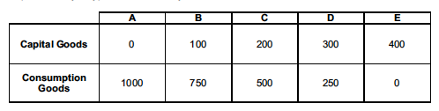

(a) (i) What is the opportunity cost of increasing capital goods production by 100 units? (1 mark)

(ii) What is the opportunity cost of shifting production from combination C to

combination B? (1 mark)

(b) (i) In the space below, graph a Production Possibility Frontier using the data from

the table. (2 marks)

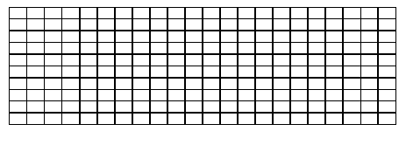

(ii) On your graph, label a point F at a combination of 300 capital goods and

500 consumption goods. (1 mark)

(iii) Explain why it is impossible for the economy to produce at point F. (2 marks)

__________________________________________________________________________________________________________________________________________________________________________________________________________________

__________________________________________________________________________________________________________________________________________________________________________________________________________________

(c) Is there a ‘best’ point of production? Explain your answer. (3 marks)

__________________________________________________________________________________________________________________________________________________________________________________________________________________

__________________________________________________________________________________________________________________________________________________________________________________________________________________

__________________________________________________________________________________________________________________________________________________________________________________________________________________

__________________________________________________________________________________________________________________________________________________________________________________________________________________

**Question 34 (10 marks)**

This question refers to the article below, which appeared in The West Australian on 30

December 2009.

WA mango lovers will pay top dollar for their favourite fruit this summer because heat and sunburn have cut supply by 50 per cent. Mangoes will start arriving in Perth from Carnarvon next week as growers work 14 hour days to get the fruit picked and sent to the market as quickly as possible. Growers in Broome and the Ord are finished for the season, so all produce will come from the Carnarvon region. The heatwave in November burnt most of the fruit, so prices are expected to be forced up to $6 each.

(a) (i) Identify one (1) factor that has caused the reduction in the supply of mangoes.

(1 mark)

______________________________________________________________________

(ii) Describe, with the use of a demand and supply diagram, the change in the

mango market. (3 marks)

________________________________________________________________________________________________________________________________________________________________________________________________________________________________________________________________________________________

Diagram:

(b) Suggest two (2) possible changes in other markets that are likely to occur as a result of the increase in the mango price. (2 marks)

__________________________________________________________________________________________________________________________________________________________________________________________________________________

__________________________________________________________________________________________________________________________________________________________________________________________________________________

______________________________________________________________________

(c) Explain how the mango market would respond if a large number of consumers were

unwilling to pay $6 for mangoes and many were left unsold. (4 marks)

__________________________________________________________________________________________________________________________________________________________________________________________________________________

__________________________________________________________________________________________________________________________________________________________________________________________________________________

__________________________________________________________________________________________________________________________________________________________________________________________________________________

__________________________________________________________________________________________________________________________________________________________________________________________________________________

____________________________________________________________________________________________________________________________________________

**Question 35 (15 marks)**

This question refers to the following hypothetical demand and supply data for recently-released DVD movies sold at a large retail store.

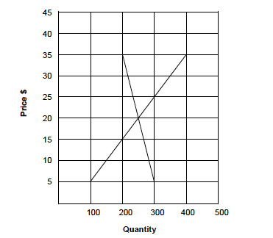

1. Use the data from the graph to complete the following table: (2 marks)

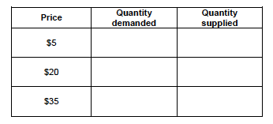

1. (i) State a formula that can be used to calculate price elasticity of demand.

(1 mark)

**__________________________________________________________________________________________________________________________________________________________________________________________________________________**

(ii) If the price was increased from $20 to $35, calculate the price elasticity of

demand coefficient. (1 mark)

____________________________________________________________________________________________________________________________________________

(iii) Is the demand for DVD movies in this price range elastic or inelastic? (1 mark)

______________________________________________________________________

(c) Outline three (3) factors that would affect the price elasticity of demand for recently released DVD movies. (3 marks)

One: __________________________________________________________________________________________________________________________________________________________________________________________________________________

Two: __________________________________________________________________________________________________________________________________________________________________________________________________________________

Three: __________________________________________________________________________________________________________________________________________________________________________________________________________________

(d) (i) The government has decided to impose a $10 sales tax on DVDs. Draw a new supply curve on the graph on page 15, demonstrating how this will affect the

market. (1 mark)

(ii) Identify the new equilibrium price and quantity in the market. (1 mark)

Price: ______________________________________________________________________

Quantity: ______________________________________________________________________

(e) Evaluate the effect of the sales tax on consumers, retailers and the government. (5 marks)

**__________________________________________________________________________________________________________________________________________________________________________________________________________________**

**__________________________________________________________________________________________________________________________________________________________________________________________________________________**

**__________________________________________________________________________________________________________________________________________________________________________________________________________________**

**__________________________________________________________________________________________________________________________________________________________________________________________________________________**

**__________________________________________________________________________________________________________________________________________________________________________________________________________________**

**Section Three: Extended response. 20% (20 marks)**

This section contains **two (2)** questions. Answer **one (1)** questions. Write your answer in the space provided and number your question clearly.

Suggested working time: 45 minutes.

**Question 35 (20 marks)**

(a) Discuss, with the use of diagrams, the main factors that affect demand and supply.

(8 marks)

(b) Demonstrate and explain how the price mechanism clears a surplus and a shortage in a market. (6 marks)

(c) Explain, with the use of examples, the significance of price, income and cross elasticity of demand. (6 marks)

**Question 36 (20 marks)**

(a) Describe the meaning of price elasticity of supply.

(4 marks)

(b) Using examples distinguish between a good that is supply elastic and one that is supply inelastic.

(5 marks)

(c) Give an example of a good that is perfectly supply inelastic.

(2 marks)

(d) Explain three (3) factors that determine price elasticity of supply.

(9 marks)